Lesson 9
Oblique Triangles

sPECIFIC OBJECTIVES:
At the end of the lesson, the student is expected to:
- Apply the Law of Sines to solve oblique triangles
- Apply the Law of Cosines to solve oblique triangles.
- Solve word problems using the Law of Sines and the Law of Cosines.

9.1 Soluion of Oblique Triangles
Solution of oblique triangles involves four cases, namely:
Case 1. Two angles and one side are given.
Case 2. Two sides and the angle opposite one of sides are given.
Case 3. Two sides and the angle between those sides are given.
Case 4. Three sides are given.

Definition 9.1 Law of Sines

For any ABC in which a, b, and c are the lengths of the sides opposite the angles with measures A, B, and C, respectively,

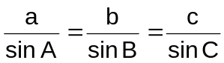

In words, the Law of Sines may be stated as follows: The sides of a triangle are proportional to the sines of the opposite angles.

Case 1: Two angles and one side are given

The law of sines can be used to find the unknown sides of an oblique triangle when two angles and one side are given.

Example 9.1.1 Solve the following triangles:

a) A = 51.3° B = 48.7° a = 24.5
b) A = 41° B = 57° c = 52
c) B = 119° C = 21° b = 59
Case 2: Two sides and the angle opposite one of the sides are given (AMBIGUOUS CASE)

When two sides and the angle opposite one of them are given, there may be no, one, or two solutions to the triangle. For this reason, Case 2 is called the ambiguous case. Below is a summary of the possible cases:

- If A is an acute angle and a < b, there are three possibilities.
C C C
b sin A

a
b b b
a a a = b sin A b sin A

A A A
B B c B

Two solutions One solution No solution
a > b sin A a = b sin A a < b sin A

- If A is an acute angle and a b, then there is exactly one solution.

C

b a

A B
c
- If A is an obtuse angle, there are two possibilities.

C C

a
a
b b

A B
A c
No solution One solution
a b a > b

Example 9.1.2 Determine how many solutions exist. When either one or two solutions exist, solve the triangle or triangles.

a) A = 67° a = 18 b = 20
b) A = 32° a = 7 b = 10
c) A = 87° a = 47 b = 50
d) A = 113° a = 49 b = 54
e) C = 108.7° a = 51.2 c = 54.3
f) B = 59.8° b = 80.8 c = 73.9

Definition 9.2 Law of Cosines

For any triangle ABC, where a, b, and c are the lengths of the sides opposite the angles with measure A, B, and C, respectively,

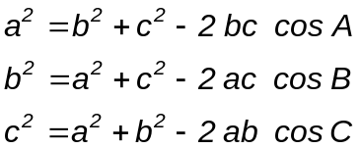

Remarks: The law of cosines is used to solve the following two additional cases of unknowns of an oblique triangle, namely:

CASE 3: Two sides and the angle between those sides are given.

CASE 4: Three sides are given

Example 9.2 Solve each triangle ABC.

a) C = 115° a = 11 b = 21
b) A = 32° b = 23 c = 47
c) a = 11 b = 14 c = 17
d) a = 23 b =43 c = 31

Definition 9.3 The Area of a Triangle

The area K of any triangle ABC is given by any one of these formulas:

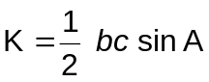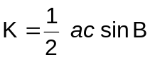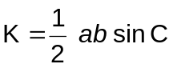

Remark:

The above formulas are used to find the area of a triangle when the measures of two sides and the included angle are known.

Example 9.3 Find the area of the given triangle.

a) A = 87.3° b = 11.3 c = 19.2
b) B = 71° a = 21 c = 87

Definition 9.4 Heron’s Formula

If a, b, and c are the measures of the sides of a triangle, then the area K of the triangle is given by

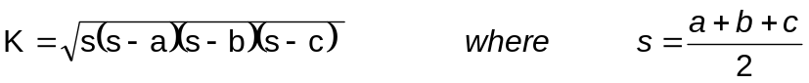

The quantity s is called the semiperimeter of a triangle.

Remark:

Heron’s formula is used to find the area of a triangle when three sides are given.

Example 9.4 Find the area of the given triangle.

a) a = 31 b = 23 c = 14
b) a = 221 b = 119 c = 246

Exercise 9.4: Solve the following problems.

- On a hill, inclined at an angle of 15.4º with the horizontal, stands a vertical tower. At a point Q, 61.5 meters down the hill from the foot of the tower, the angle of elevation of the top of the tower is 42.6º. How tall is the tower?

- A flagpole is situated at the top of a building 120 ft tall. From a point in the same horizontal plane as the base of the building, the angles of elevation of the top and bottom of the flagpole are 73.2º and 67.2º, respectively. How tall is the flagpole?

- A ladder 42.5 ft long is leaning against an embankment inclined 58.5° to the horizontal. If the bottom of the ladder is 12.5ft from the embankment, what is the distance from the top of the ladder down the embankment to the ground?

- Two ships leave the same port at the same time. One ship sails on a course of 120º at 16 knots while the other sails on a course of 220º at 23 knots. Find after 3 hours (a) the distance between the ships and (b) the bearing from the first ship to the second.

